C155
Programming Assignment 1
Brionna Morris
27 January 2026

Analysis:
- Definition
The program will use a formula to compute future investment value from user input that must include the investment amount, annual interest rate, and the number of years.
- Input
  - Investment Amount: investmentAmount (integer – int)
  - Annual Interest Rate: annualInterestRate (double)
  - Number of Years: numberOfYears (integer – int)
  - (Monthly Interest Rate: monthlyInterestRate (double)
- Process
  - monthlyInterestRate = annualInterestRate /12/100) this changes to rate and calculates monthly.
  - futureInvestmentValue = investmentAmount * (1 + monthlyInterestRate)^{numberOfYears*12}
- Output
  - Future Investment Value: futureInvestmentValue (double)
- Requirements
  - Input Prompts
    - “Enter investment amount: ”
    - “Enter annual interest rate: ”
    - “Enter the number of years: ”
  - Output Label
    - “Accumulated value is ”
  - Output Formats
    - Future Investment Value is 2 digits after the decimal point (currency).
Design:
- Pseudo Code:
  - Declare and intialize variables for user input using Scanner for investmentAmount, annualInterestRate, numberOfYears, monthlyInterestRate, futureInvestmentValue.
  - Display investmentAmount input prompt
  - Display annualInterestRate input prompt
  - Display numberOfYears input prompt
  - Compute monthly interest by 12 months and into a rate (100) instead of percentage
  - Compute futureInvestmentValue based on provided formula
  - Display futureInvestmentValue in digits after the decimal point (currency).
Code:
/**
* The program will use a formula to compute future investment value
* from user input that must include the investment amount,
* annual interest rate, and the number of years.
*
* @ author: Brionna Morris
* @version: PA01
* @since: 27 January 2026
* */
// importing the Scanner class for user input later in program
import java.util.Scanner;
public class ComputeFutureValue{
public static void main(String[] args){
Scanner input = new Scanner(System.in);
//declaring and initializing the investmentAmount with integer type
int investmentAmount;
investmentAmount = 0;
//declaring and initializing the annualInterestRate with double type
double annualInterestRate;
annualInterestRate = 0.00;
//declaring and initializing the numberOfYears with integer type
int numberOfYears;
numberOfYears = 0;
//declaring and initializing the monthlyInterestRate with double type
double monthlyInterestRate;
monthlyInterestRate = 0.00;
//declaring and initializing the futureInvestmentValue with double type
double futureInvestmentValue;
futureInvestmentValue = 0.00;
//Prompts user to input investment amount
System.out.print("Enter investment amount: ");
investmentAmount = input.nextInt();
//Prompts user to input annualInterestRate
System.out.print("Enter annual interest rate: ");
annualInterestRate = input.nextDouble();
//Prompts user to input numberOfYears
System.out.print("Enter number of years: ");
numberOfYears = input.nextInt();
//computing monthly interest rate by 12 months and into a rate instead of percentage
monthlyInterestRate = annualInterestRate / 12 / 100;
//computation of futureInvestmentValue based on user input, variables, and provided formula
futureInvestmentValue = investmentAmount * Math.pow((1 + monthlyInterestRate), numberOfYears * 12);
//output will provide user with futureInvestmentValue to the 2nd point (currency)
System.out.printf("Accumulated value is: %.2f%n", + futureInvestmentValue);
}
}
Testing:
Prepared Input | Executed Output
Sample Run 1: Course Case  Investment Amount: 1000  Annual Interest Rate: 3.25  Number of Years: 1  Expected Accumulated Value is 1032.99 | Run 1:  Investment Amount: 1000  Annual Interest Rate: 3.25  Number of Years: 1  Accumulated Value: 1032.99

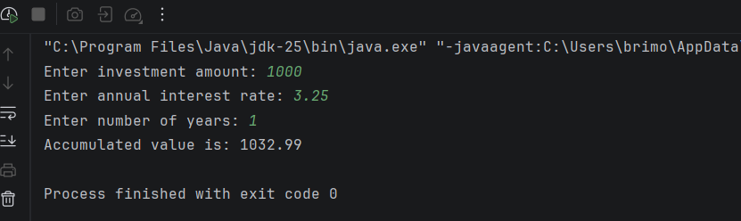

Prepared Input | Executed Output
Sample Test 1: My Case  Investment Amount: 727000  Annual Interest Rate: 8.64  Number of Years: 12  Expected Accumulated Value is 2042667.47 | Test 1:  Investment Amount: 727000  Annual Interest Rate: 8.64  Number of Years: 12  Accumulated Value: 2042667.47
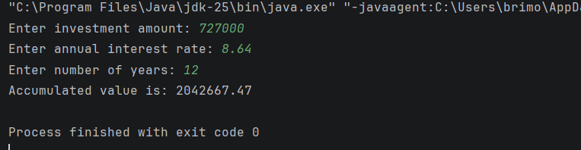
Prepared Input | Executed Output
Sample Test 2: My Case  Investment Amount: 15000  Annual Interest Rate: 1.38  Number of Years: 23  Expected Accumulated Value is 20599.52 | Test 2:  Investment Amount: 15000  Annual Interest Rate: 1.38  Number of Years: 23  Accumulated Value: 20599.52

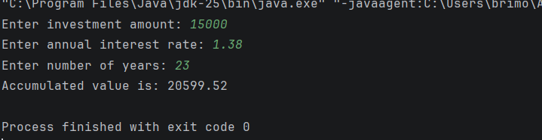
Prepared Input | Executed Output
Sample Test 3: My Case  Investment Amount: 55487  Annual Interest Rate: 6.75  Number of Years: 60  Expected Accumulated Value is 3148875.45 | Test 3:  Investment Amount: 55487  Annual Interest Rate: 6.75  Number of Years: 60  Accumulated Value: 3148875.45

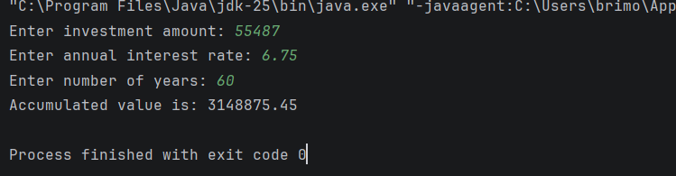

Prepared Input | Executed Output
Sample Test 4: My Case  Investment Amount: 25  Annual Interest Rate: 23.84  Number of Years: 10  Expected Accumulated Value is 264.94 | Test 4:  Investment Amount: 25  Annual Interest Rate: 23.84  Number of Years: 10  Accumulated Value: 264.94

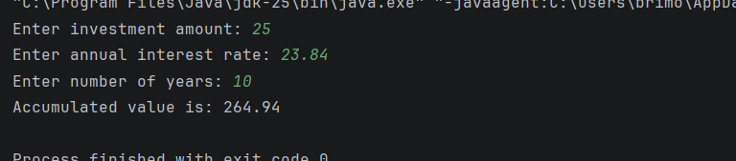
Prepared Input | Executed Output
Sample Test 5: My Case  Investment Amount: 731  Annual Interest Rate: .29  Number of Years: 52  Expected Accumulated Value is 849.97 | Test 5:  Investment Amount: 731  Annual Interest Rate: .29  Number of Years: 52  Accumulated Value: 849.97

